  



|  |  |  |
| --- | --- | --- |
| Minutes | | |
| **SONIA Stakeholder Advisory Group** | | |
| 23 September 2019 | | |
| **Location:** | | Bank of England |
| **Minute no.** | **Minute** | |
| 1. | **The role of the SONIA Stakeholder Advisory Group**  The meeting was attended by Dave Ramsden (Deputy Governor, Markets and Banking; accountable senior manager for SONIA) and Jo Place (the Bank’s COO and chair of the SONIA Oversight Committee). They provided their perspectives on the Group’s role and how it fits into the Bank’s administration of SONIA. Both Governors thanked members for their time and said the market views provided by the Group had provided helpful input enabling the Oversight Committee to discharge its responsibilities and supported the Bank’s administration of SONIA. | |
| 2. | **Review of market conditions**  The Bank presented a pack of publically available statistics on the SONIA rate and volumes, and on SONIA adoption since the reforms were implemented.1  The SONIA rate continued to be stable and had increased slowly since the Group’s February meeting, with the basis to Bank Rate now consistently around 4 basis points. The Group noted that, as discussed at the previous meeting, the market has now been better prepared for period- ends and start planning well ahead of the event. This was again evident on June half year-end when the SONIA rate remained virtually unchanged. The volumes increased over the summer to around £41bn, which the Group felt could be due to seasonal effects; similar increases were observed across different markets. The Bank shared with the Group charts showing the concentration of participants in the underlying market was broadly unchanged since the Bank had taken on publication in April 2018 and was marginally down on the levels published as a part of the SONIA reform consultation.2 This was viewed as reassuring.  The Group discussed recent volatility in the US Treasury repo markets; it was noted there had been no spillover into sterling money markets.  Looking forward, the Group acknowledged continued market uncertainty around terms of the UK’s withdrawal from the EU and discussed potential impact on SONIA. The position was considered largely unchanged from February.3 | |
| 3. | **SONIA borrowers’ requirements, capacity and ability to borrow**  Following on from the discussion at the February meeting on the EU MMF Regulation reform and MMFs’ role in the SONIA market, the Group discussed the role of borrowers and the drivers and constraints on their participation. | |

1 Appended to these minutes.

2 Appended to these minutes.

3 Item 2, Minutes of the 21/02/19 meeting: [www.bankofengland.co.uk/-/media/boe/files/minutes/2019/sonia-stakeholder-](http://www.bankofengland.co.uk/-/media/boe/files/minutes/2019/sonia-stakeholder-advisory-group-21-february-2019.pdf) [advisory-group-21-february-2019.pdf](http://www.bankofengland.co.uk/-/media/boe/files/minutes/2019/sonia-stakeholder-advisory-group-21-february-2019.pdf)

|  |  |
| --- | --- |
|  | An important driver for banks’ activity was how monetary policy was implemented. The current floor based system in sterling meant there was excess cash in the system. As a result, banks did not necessarily need to borrow in the market to meet their day to day liquidity needs; their activity is then balanced against its impact on their regulatory liquidity ratios, specifically the Net Stable Funding Ratio (NSFR) and Liquidity Coverage Ratio (LCR). It was noted that for banks who were not solely regulated by the PRA, the approach of other regulators affected their activity in the sterling markets. An example of this was the different treatment of reserves held at central banks in the calculation of liquidity ratios which limited some banks’ activity. The Group’s view was that PRA’s interpretation better reflected the original intention of the regulations. |
| 4. | **SONIA contingency arrangements**  The short-term contingency arrangements for SONIA were reviewed.4 The Group’s view was that the policies were clear and understandable. They noted that were the contingency arrangements for calculating the rate to be invoked, transparent and clear communication would be appreciated by the market.  It was confirmed that the anticipated trigger for the use of these arrangements would be an operational issue; a response to any future change in the structure of the underlying market would be considered using the published policies relating to the review and evolution of the methodology.5 |
| 5. | **Evolving uses of SONIA**  There had been a further increase in issuance of SONIA based FRNs and use of SONIA referencing derivatives since the last meeting. The first SONIA referencing loans and transactions of SONIA swaptions had also been reported. It was agreed to discuss at a future meeting if there were any implications from these developments for the administration of SONIA.  It was noted that there remained some lack of visibility on precise terms of certain privately placed instruments, which was limiting activity in secondary markets. The Bank said it would pass this feedback to the Sterling Risk Free Rates Working Group who were best placed to consider how to address this point.  It was suggested that the forthcoming launch of €STR and the related increase in engagement of investors in euro markets in RFR adoption could prompt more activity in SONIA markets given increased synergies. |
| 6. | **Future discussion topics**  In the light of the ongoing uncertainty over the terms of the UK’s withdrawal from the EU, as was the case following the Group’s February meeting, the Chair noted it may be appropriate for the Group to meet ahead of its next scheduled meeting in the spring. |

4 See Section 5 of the SONIA Key features and policies: [www.bankofengland.co.uk/markets/sonia-benchmark/sonia-key-](http://www.bankofengland.co.uk/markets/sonia-benchmark/sonia-key-features-and-policies) [features-and-policies](http://www.bankofengland.co.uk/markets/sonia-benchmark/sonia-key-features-and-policies)

5 See Section 8 of the SONIA Key features and policies.

**Attendees:**

Chair Richard Moore (Independent member of SONIA Oversight Committee) External Member Julia Black (Independent member of SONIA Oversight Committee) Goldman Sachs Nikhil Choraria

HSBC James Murphy Insight Investment Robert Gall

ICE Futures Matthew Horton

ISDA Jonathan Martin

JP Morgan AM Olivia Maguire

LCH Philip Whitehurst

LGIM John Wherton

Mizuho Rob Thurlow RBC Capital Markets Sean Taor RBS Donal Quaid

Société Generalé Romain Sinclair TP ICAP Philip Chilvers

Bank of England Jo Place

Dave Ramsden Will Parry

Tom Horn

Joanna McLafferty

**SONIA Stakeholder Advisory Group**

September 2019

# Published SONIA statistics

## Chart 1: SONIA volumes

£Bns

60

50

40

30

20

10

0

Aug-18 Sep-18 Oct-18 Nov-18 Dec-18 Jan-19 Feb-19 Mar-19 Apr-19 May-19 Jun-19 Jul-19 Aug-19 Sep-19

*Source: Bank of England*

## Chart 2: SONIA rates and percentiles

25th - 75th percentiles 10th - 90th percentiles SONIA

Percent 0.80

0.75

0.70

0.65

0.60

Aug-18 Sep-18 Oct-18 Nov-18 Dec-18 Jan-19 Feb-19 Mar-19 Apr-19 May-19 Jun-19 Jul-19 Aug-19 Sep-19

# Usage of SONIA

Chart 3: SONIA Futures - monthly nominal volumes and open interest at month end*

£1.0

Trillions

£0.9

£0.8

£0.7

£0.6

£0.5

£0.4

£0.3

£0.2

£0.1

£0.0

Jul-18

Jul-19

Aug-19

ICE 3M CME 3M IMM ICE 1M CurveGlobal 3M CME MPC Open Interest

May-18

Jun-18

Aug-18

Sep-18

Oct-18

Nov-18

Dec-18

Jan-19

Feb-19

Mar-19

Apr-19

May-19

Jun-19

*Source: ICE Futures, Curve Global and CME Group*

*\* Lots traded multiplied by nominal lot size*

Chart 4: Volume distribution of FRN issuances

100%

80%

60%

40%

no issuance

20%

0%

Jun-18

Jul-18

Aug-18

Sep-18

Oct-18

Nov-18

Dec-18

Jan-19

Feb-19

Mar-19

Apr-19

May-19

Jun-19

Jul-19

Aug-19

SONIA LIBOR

*Source: Bloomberg L.P. and Bank of England Calculations*

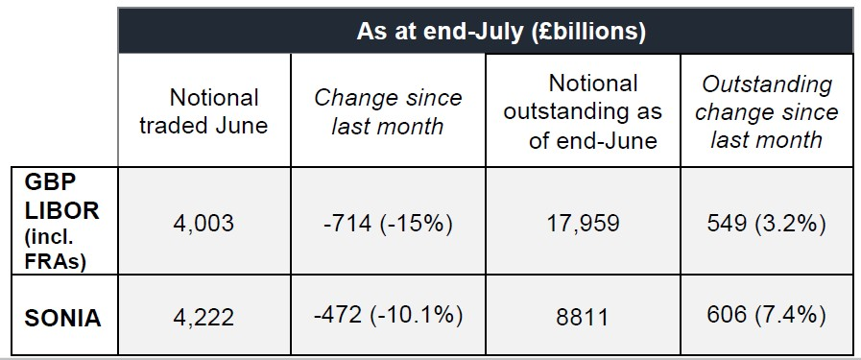Table 1: LCH Swap Statistics

# Concentration of borrowers in the underlying market

Top 5 Top 10 Top 15 Top 20

100%

80%

60%

40%

20%

0%

Apr-18 May-18 Jun-18 Jul-18 Aug-18 Sep-18 Oct-18 Nov-18 Dec-18 Jan-19 Feb-19 Mar-19 Apr-19 May-19 Jun-19 Jul-19 Aug-19

*Source: Bank of England SMMD collection*